Project Design Phase
Solution Architecture

Date | 15 February 2026
Team ID | LTVIP2026TMIDS81358
Project Name | OrderOnTheGo : Your On-Demand Food Ordering Solution
Maximum Marks | 4 Marks

Solution Architecture:
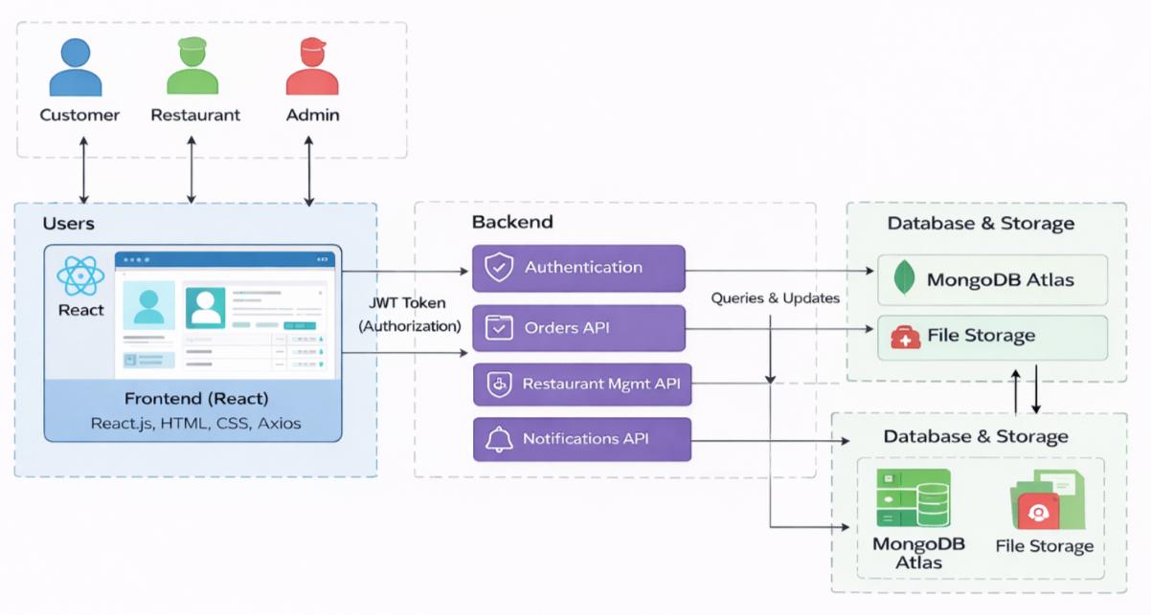
Figure-1: Architecture and data flow of the OrderOnTheGo MERN-stack food ordering platform.

